Distributives Determiners

🔄 What Are Distributives (Types of Determiners)?
# Source: AI Source: Provided by: [Data Path: Persons Table -> ID Column: 1, Name_En Column: Motasem Essam] -> From: [Chatgpt (GPT-4-turbo)] on [7/28/2025]
Distributive determiners refer to individual members of a group separately, rather than the group as a whole. They show how something is distributed among members of a set.

✅ Common Distributive Determiners:
# Source: AI Source: Provided by: [Data Path: Persons Table -> ID Column: 1, Name_En Column: Motasem Essam] -> From: [Chatgpt (GPT-4-turbo)] on [7/28/2025]
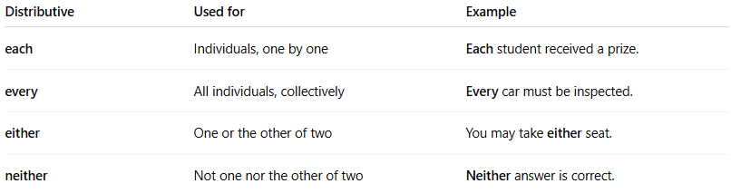
Distributive | Used for | Example
each | Individuals, one by one | Each student received a prize.
every | All individuals, collectively | Every car must be inspected.
either | One or the other of two | You may take either seat.
neither | Not one nor the other of two | Neither answer is correct.

🔍 Key Differences:
# Source: AI Source: Provided by: [Data Path: Persons Table -> ID Column: 1, Name_En Column: Motasem Essam] -> From: [Chatgpt (GPT-4-turbo)] on [7/28/2025]

Each vs Every
✅ Each emphasizes individuals separately.
✅ Every focuses on the group as a whole.
Examples:
- Each boy has a pencil. (individual focus)
- Every boy in the class is present. (group focus)

📝 Notes:
# Source: AI Source: Provided by: [Data Path: Persons Table -> ID Column: 1, Name_En Column: Motasem Essam] -> From: [Chatgpt (GPT-4-turbo)] on [7/28/2025]
- These determiners are always followed by a singular noun.
  - ✅ Correct: Each child is happy.
  - ❌ Incorrect: Each children is happy.

